|  |  |  |  |  |  |
| --- | --- | --- | --- | --- | --- |
| **Module No:** | 1 | **IU No:** | 4 | **Exercise No.** | 1 |

|  |  |
| --- | --- |
| **Lab Assessment Statement** | **Assignment 4 - Spring Boot + JPA**  **Let’s build on the previous assignment.**   1. **Create a Spring Boot application for “Know-Your-Neighborhood”.** 2. **Add support for JSP views and create required folder structure.** 3. **Move already developed classes into this project.** 4. **Create store table in the database** 5. **Annotate all the fields of Store object appropriately.** 6. **Develop all components required to view the stores**    1. **Add method to existing Controller class to receive the request to fetch stores**    2. **Enhance Store service and Store Controller objects to support CRUD operations on store object.**    3. **Add method existing repository class to perform crud operations on Store object.**    4. **Create HTML to view the stores. Show name, phone number and localities it serves for each store.**    5. **Ensure that view stores request works end-to-end. (i.e., should be able to submit request to view the stores in the browser and get the page back with all stores).** 7. **Create an HTML page to perform Add store, Fetch stores, Update store, & Delete store operations from the UI.** |
| **Technical Environment** | - |
| **Guidelines** | - |
| **Duration** | 120 mins |

1. **Create a Spring Boot application for “Know-Your-Neighborhood”.**

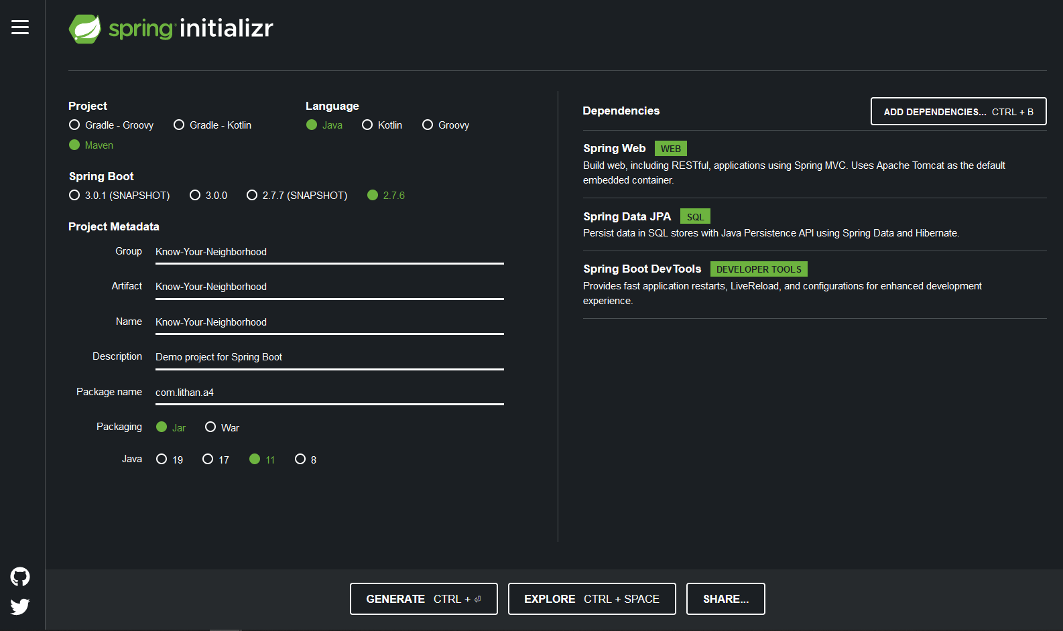

1. **Add support for JSP views and create required folder structure.**



1. **Move already developed classes into this project.**

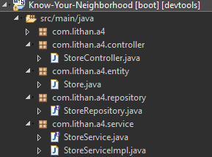

1. **Create store table in the database**

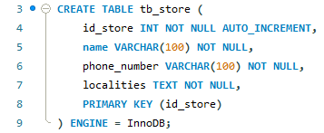



1. **Annotate all the fields of Store object appropriately.**

**Store**

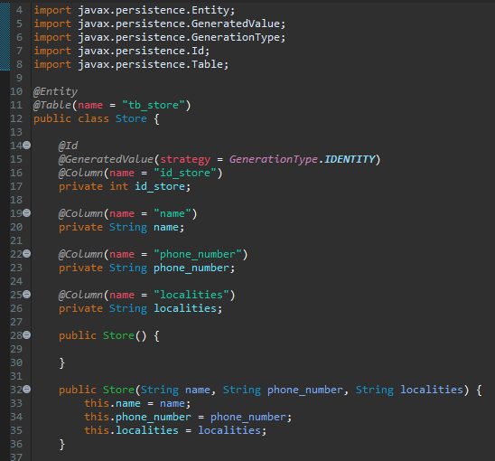

1. **Develop all components required to view the stores**
   1. **Add method to existing Controller class to receive the request to fetch stores**

**StoreController**

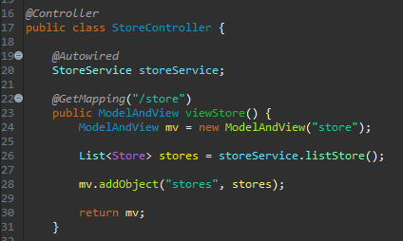

* 1. **Enhance Store service and Store Controller objects to support CRUD operations on store object.**
  2. **Add method existing repository class to perform crud operations on Store object.**

**StoreService**

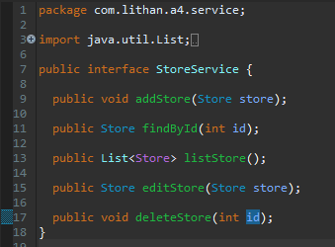

**StoreServiceImpl**

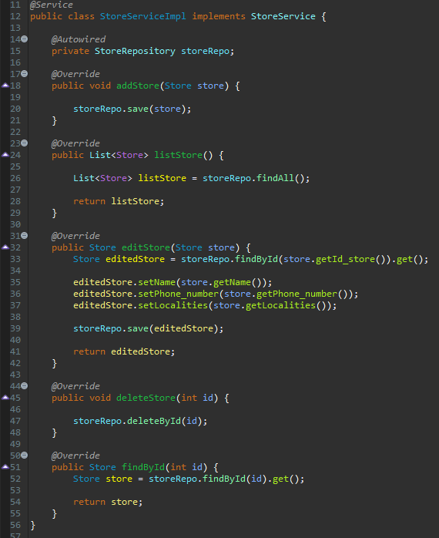

**StoreController**

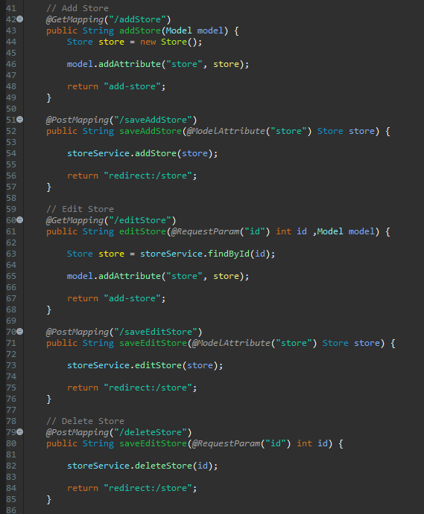

* 1. **Create HTML to view the stores. Show name, phone number and localities it serves for each store.**

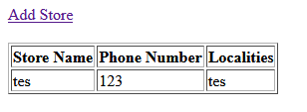

* 1. **Ensure that view stores request works end-to-end. (i.e., should be able to submit request to view the stores in the browser and get the page back with all stores).**

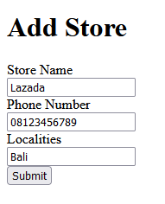 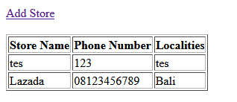

**Database (Before)**

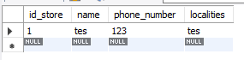

**Database (After)**

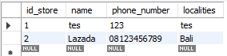

1. **Create an HTML page to perform Add store, Fetch stores, Update store, & Delete store operations from the UI.**

**Add Store**

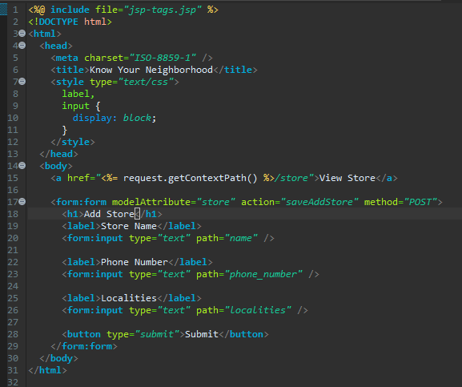



**View Store**

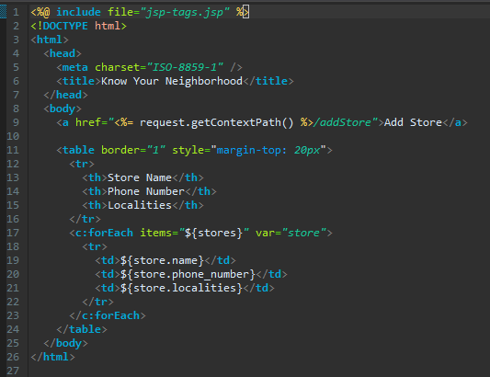



**Update Store**

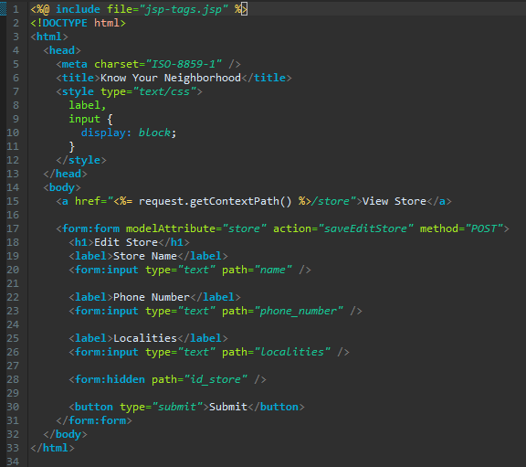

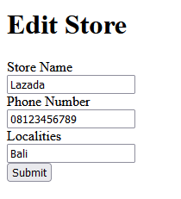

**Delete Store**

**Before Delete**

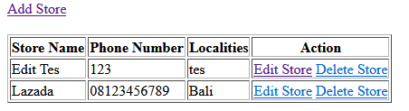



**After Delete**



